Weekly Coding Exercise #3

Task:

“Connect up multiple interpolation scripts to a scene in Unity. Show how the scripts are connected together and show the result.”

Result:

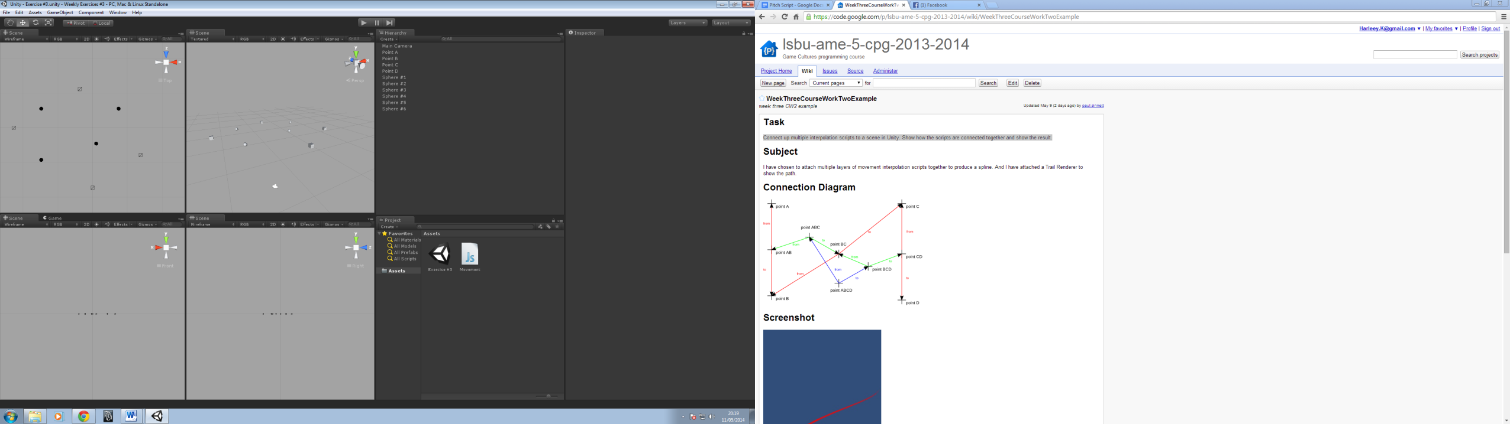

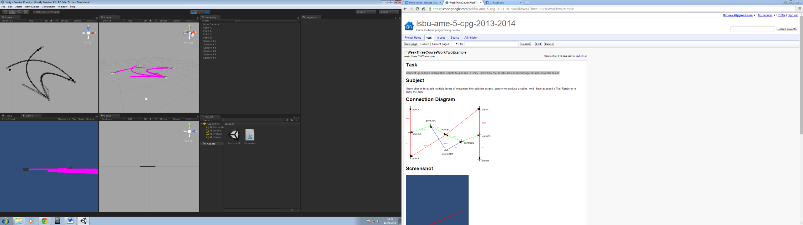

Development Log:

|  |  |  |  |  |  |  |
| --- | --- | --- | --- | --- | --- | --- |
| Exercise | Task | Date | Start | End | Interruptions | Hours |
| Weekly Exercise #03. |  | 08/05/2014 |  |  |  |  |
|  | Decided the problem. |  | 3:00 | 3:05 |  | 0.05 |
|  | Developed Unity Scene. |  | 3:05 | 3:10 |  | 0.05 |
|  | Wrote and checked code. |  | 3:10 | 3:25 |  | 0.15 |
|  | Screen shot of work. |  | 3:25 | 3:35 | Conversation | 0.10 |